A Report
On

Unmasking Deception: A Novel Approach to Face Swap
Deepfake Identification via Geometric Interpolation
carried out as part of the course Project Based Learning

Submitted by
Aakash Kushwaha
Registration No: 23FE10CSE00344
VI Semester

in partial fulfilment for the award of the degree
of
BACHELOR OF TECHNOLOGY
In
Computer Science & Engineering


Department of Computer Science & Engineering,
School of Computer Science and Engineering,
Manipal University Jaipur,
Jan-May 2026
Date: 13 April 2026

CERTIFICATE
This is to certify that the project entitled "Unmasking Deception: A Novel Approach to Face Swap Deepfake Identification via Geometric Interpolation" is a bonafide work carried out as PBL-4 End Term Assessment in partial fulfilment for the award of the degree of Bachelor of Technology in Computer Science and Engineering, by Aakash Kushwaha bearing registration number 23FE10CSE00344, during the academic semester VI of year 2025-2026.

Place: Manipal University Jaipur, Jaipur

Name of the project guide: Mr. Lav Upadhyay

Signature of the project guide: ________________________

Acknowledgement
This project would not have been completed without the help, support, comments, advice, cooperation and coordination of various people. However, it is impossible to thank everyone individually; I am hereby making a humble effort to thank some of them.
I acknowledge and express my deepest sense of gratitude to my internal supervisor Mr. Lav Upadhyay for his constant support, guidance, and continuous engagement throughout this work. I highly appreciate his technical comments, suggestions, and constructive criticism during the progress of this project titled "Unmasking Deception: A Novel Approach to Face Swap Deepfake Identification via Geometric Interpolation". His mentorship was central to shaping the rigour, direction, and final outcome of this research.
I owe my profound gratitude to Dr. Neha Chaudhary, Head, Department of CSE, for her valuable guidance and for facilitating me during my work. I am also very grateful to all the faculty members and staff of the Department of Computer Science and Engineering for their precious support and cooperation during the development of this project.
I extend my sincere thanks to the reviewers of IEEE Access whose detailed feedback during the major revision phase strengthened the manuscript significantly. I am especially thankful for their patience and the depth of engagement they brought to the review process, which directly influenced the final shape of the contributions presented in this report.
Finally, I extend my heartfelt appreciation to my classmates for their help and encouragement throughout the duration of this project.

Aakash Kushwaha
Registration No: 23FE10CSE00344

Abstract
Deepfake technology has advanced to a point where face swap manipulations can produce nearly indistinguishable forgeries, raising serious concerns around privacy, security, and digital trust. Most existing detection approaches frame the problem as supervised classification, training large neural networks on collections of labeled fake data. While such methods perform well within their training distribution, they tend to break down when faced with novel manipulation pipelines or any cross-dataset evaluation. This work takes a fundamentally different approach. Rather than learning what fakes look like, the proposed framework asks whether a face in a video genuinely belongs to its claimed identity, reformulating face swap detection as a geometric verification problem in face recognition embedding space.
Building on the FACTOR fact-checking paradigm, three novel scoring methods are introduced that require no training on deepfake data whatsoever. The primary contribution, Inter-Identity Betweenness Geometry, models face swap deepfakes as geometric interpolations between source and target identity centroids in embedding space, achieving 99.99% AUC on Celeb-DF v2 and 99.97% on FaceForensics++ Deepfakes. Two complementary methods are also proposed: Negative Margin Scoring, which detects source identity leakage by comparing similarity to the claimed identity against competing identities and reaches 99.90% AUC on Celeb-DF v2; and Statistical Identity Modeling, which replaces the single maximum similarity used by FACTOR with the full distribution of reference similarities, reaching 99.80% AUC.
Evaluation spans two standard benchmarks comprising 11,935 videos across 1,059 identities, four manipulation types, and two compression levels. The betweenness method is remarkably efficient, requiring as few as four reference frames per identity while dropping only 0.03% AUC under heavy compression. Source identity detection analysis confirms that the geometric framework correctly identifies the actual donor face used to create a deepfake in 96.2% of cases, providing direct empirical validation of the underlying geometric theory. Comprehensive ablation studies, bootstrap confidence intervals, failure case analysis, and per-manipulation breakdowns are provided. In the interest of scientific transparency, it is acknowledged that identity-based methods fundamentally cannot detect reenactment manipulations such as Face2Face and NeuralTextures, since these preserve the subject's identity rather than replacing it.
The research conducted as part of this project has been accepted for publication in IEEE Access (Manuscript ID: Access-2026-03062), one of the leading peer-reviewed open-access journals in the IEEE family. The paper is scheduled for publication on IEEE Xplore within seven to eight days from the date of this report.

Keywords: Deepfake detection, face-swap detection, identity verification, face recognition embeddings, geometric embedding analysis, ArcFace, compression robustness, IEEE Access.

Table of Contents
Abstract iv
List of Figures vi
List of Tables vii
1. Introduction 1
1.1 Motivation 2
1.2 Background and Context 3
2. Literature Review 5
2.1 Deepfake Generation Techniques 5
2.2 Supervised Detection Methods 6
2.3 Identity-Based Detection 8
2.4 Comparative Summary of Existing Methods 9
2.5 Outcome of Literature Review 10
2.6 Problem Statement 11
2.7 Research Objectives 11
3. Methodology and Framework 12
3.1 System Architecture and Overall Pipeline 12
3.2 FACTOR Baseline 14
3.3 Inter-Identity Betweenness Geometry 15
3.4 Negative Margin Scoring 17
3.5 Statistical Identity Modeling 18
3.6 Source Identity Detection (Validation Tool) 19
3.7 Video-Level Aggregation and Decision 20
4. Work Done 21
4.1 Datasets and Experimental Setup 21
4.2 Implementation Details 22
4.3 Results and Discussion 23
4.4 Cross-Dataset Generalization 25
4.5 Compression Robustness Analysis 26
4.6 Reference Set Size Ablation 27
4.7 Source Identity Detection Validation 28
4.8 Failure Case Analysis 29
5. Conclusion and Future Plan 30
6. Outcome — IEEE Access Acceptance 31
7. References 32

List of Figures
Figure 1: End-to-end detection pipeline overview 13
Figure 2: Comparison of FACTOR baseline with proposed methods 15
Figure 3: Inter-identity betweenness geometry concept 16
Figure 4: ROC curves on key datasets 24
Figure 5: Compression robustness comparison 26
Figure 6: Reference set size impact on Celeb-DF v2 27

List of Tables
Table 1: Summary of deepfake detection techniques 9
Table 2: Benchmark datasets used in the study 21
Table 3: Main results — video-level AUC across all conditions 23
Table 4: Bootstrap 95% confidence intervals 24
Table 5: Compression robustness results 26
Table 6: Reference set size ablation 27
Table 7: Source identity detection rates 28

1. Introduction
The rapid maturation of generative artificial intelligence has fundamentally altered what is possible in synthetic media. Among the most consequential developments in this space is the emergence of deepfake technology, a class of techniques powered primarily by generative adversarial networks and autoencoder architectures that can convincingly substitute one person's face for another in video content. What began as a niche academic curiosity has, within the span of less than a decade, grown into a phenomenon with significant societal implications. Fabricated videos of public figures have appeared on social media platforms, designed to influence elections and shape public opinion. Non-consensual face-swapped content has caused severe and irreversible personal harm to victims. By some estimates, over ninety-five percent of deepfake content currently circulating online is non-consensual, and the total volume of manipulated media doubles approximately every six months.

These figures paint a troubling picture, one in which the tools of manipulation are advancing faster than the tools of detection. Yet it would be intellectually dishonest to frame deepfake technology as purely malicious. The same generative architectures enable face-swapping in legitimate and beneficial applications: film studios use face synthesis for de-aging actors and completing principal photography after an actor's untimely death; educational content creators bring historical figures to life in ways that textbooks alone cannot; virtual reality and telepresence systems depend on realistic facial rendering for immersive experiences. The challenge is therefore not to suppress the technology itself, which would be both impractical and counterproductive, but to develop reliable methods that can distinguish authentic media from manipulated content when the distinction matters.
1.1 Motivation
The research community has responded to the deepfake challenge with considerable energy. Over the past several years, a rich and diverse ecosystem of detection methods has emerged, spanning from convolutional neural network classifiers to recurrent architectures capable of capturing temporal inconsistencies, frequency-domain analysis, vision transformers, and large-scale community benchmarks such as the Deepfake Detection Challenge organized by Facebook AI in partnership with Microsoft. Despite this progress, a persistent and somewhat frustrating limitation remains. The overwhelming majority of existing detection methods are supervised classifiers, trained on carefully curated collections of real and fake data. As a consequence, they tend to degrade, sometimes dramatically, when confronted with manipulation techniques absent from their training distribution. A FaceForensics++-trained detector typically performs poorly on Celeb-DF forgeries because the synthesis pipelines differ. The XceptionNet model, a widely cited supervised baseline, achieves around ninety-nine percent accuracy on seen manipulations but falls below eighty percent on unseen ones.

This observation motivated a different line of inquiry. Rather than asking whether a video contains artifacts consistent with known fakes, what if the question were reframed as whether the face in a video genuinely belongs to its claimed identity? The first formulation depends on the specific synthesis technique and changes whenever a new generator is released. The second requires only knowledge of what a particular real person looks like, which remains stable regardless of how deepfake technology evolves. This shift in framing forms the conceptual heart of the present work and connects directly to the FACTOR framework proposed by Reiss and colleagues, which demonstrated that competitive detection performance is achievable using only identity verification, without ever training on deepfake data.

The motivation, then, is to push this insight further. The FACTOR framework asks only whether a test face matches its claimed identity. It does not examine the inter-identity geometric structure of the embedding space, which carries a strong and unexploited signal for face-swap detection. When a face-swap algorithm blends a source face onto a target identity, the resulting embedding does not move arbitrarily through the space. Instead, it moves toward the source identity, creating a predictable geometric pattern that maximum-similarity scoring alone cannot fully capture. The work presented in this report directly addresses this gap.

1.2 Background and Context
Modern face recognition systems, particularly those built on the ArcFace architecture trained with the additive angular margin loss, produce 512-dimensional embedding vectors that occupy a hyperspherical manifold. Within this manifold, individuals form tight, well-separated clusters. The training objective explicitly maximizes inter-class separation and minimizes intra-class variance, properties that turn out to be directly exploitable for deepfake detection even though the models were never trained for that application. The compactness of identity clusters is precisely what makes interpolation detection feasible: even a modest displacement of an embedding toward a different identity pushes it into the gap between clusters, where geometric methods can reliably detect it.

Two benchmark datasets dominate evaluation in this field. FaceForensics++ contains roughly one thousand original YouTube videos manipulated by four distinct techniques, providing both face-swap manipulations (Deepfakes and FaceSwap) and reenactment manipulations (Face2Face and NeuralTextures). Celeb-DF v2 raised the quality bar substantially with a synthesis pipeline that reduced common artifacts such as color mismatch, visible boundaries, and temporal flickering. Its fifty-nine identities and over five thousand deepfake videos make it the standard benchmark for evaluating cross-dataset generalization. The work presented in this report evaluates on both datasets and across all six relevant test conditions, including a heavy-compression scenario that simulates realistic distribution channels.

This report documents the full project: from the literature review that identified the research gap, through the methodology and theoretical formulation, to the experimental validation that culminated in acceptance for publication in IEEE Access. The structure follows the prescribed format for research-oriented projects, providing a comprehensive account of every aspect of the work and ending with an explicit description of the publication outcome that the project has produced.

2. Literature Review
The deepfake detection landscape has evolved rapidly over the past half decade and is shaped by an arms race between increasingly sophisticated generation techniques and the methods designed to counter them. This chapter surveys the generative techniques used to produce deepfakes, the supervised detection paradigms that dominate the field, the emerging identity-based alternatives that motivate the present approach, and the benchmark datasets against which all methods are measured. The chapter closes by summarizing the specific gap that the proposed contributions address.
2.1 Deepfake Generation Techniques
Understanding how deepfakes are created is in many ways a prerequisite for understanding why detecting them is so difficult. The earliest face-swap systems relied heavily on autoencoder architectures, in which a shared encoder learns a common facial representation while separate decoders reconstruct the faces of two different individuals. By swapping decoders at inference time, these systems generate a face that carries the identity of one person rendered onto the facial structure of another. The original DeepFakes method, which lent its name to the entire phenomenon, followed exactly this recipe. Generative adversarial networks subsequently moved the quality ceiling considerably higher. The well-known StyleGAN family demonstrated that synthesized faces could become virtually indistinguishable from real photographs to the untrained eye.
FaceSwap, an open-source tool, takes a more geometric approach by fitting three-dimensional face models and performing texture mapping. Face2Face and NeuralTextures operate fundamentally differently from face-swap methods: they modify facial expressions or textures while preserving the subject's identity. This distinction between identity-replacing manipulations and identity-preserving manipulations is one that recurs throughout this report, because it defines the core boundary of application for any identity-based detection method. More recently, diffusion models have begun producing synthetic faces of remarkable quality and diversity, posing new challenges to detectors developed primarily against GAN-based forgeries. The generation landscape is, in a meaningful sense, a moving target, and any detection approach that depends on recognizing generator-specific artifacts is at risk of obsolescence with each new synthesis technique released.
2.2 Supervised Detection Methods
The dominant paradigm in deepfake detection remains supervised binary classification: a deep network is trained on labeled real and fake data and then used to classify unseen samples. This approach has produced impressive in-domain results but carries a structural vulnerability that becomes more visible as the field matures. CNN-based approaches such as MesoNet target real-time deployment with shallow architectures, achieving around eighty-nine percent accuracy on training distributions but limited generalization. XceptionNet, adapted from depthwise separable convolutions, reaches ninety-nine percent accuracy on FaceForensics++ when trained and tested on the same manipulation type, yet drops to roughly sixty-five percent in cross-dataset evaluation on Celeb-DF, a decline of over thirty percentage points. Many other CNN architectures have been explored, including constrained convolutional layers, steganalysis-inspired features, and Siamese network variants, but none has convincingly solved the cross-dataset generalization problem.

Temporal and sequence-based methods exploit the fact that deepfakes are videos rather than still images. Early work combined convolutional networks with recurrent layers to capture frame-to-frame inconsistencies. Sabir and colleagues extended this with three-dimensional convolutions and bidirectional LSTMs, reaching about eighty-five percent on FaceForensics++. Li and colleagues demonstrated that early deepfakes exhibited unnatural blinking patterns, although this cue has been largely neutralized by modern generators that explicitly model eye behavior. The temporal consistency hypothesis deserves particular attention here because it connects directly to one of the findings of the present work: ablation experiments confirmed that modern high-quality deepfakes maintain frame-to-frame coherence essentially indistinguishable from real videos, with temporal consistency scoring achieving only sixty-four percent AUC on Celeb-DF v2 and dropping to forty percent under heavy compression.

Frequency-domain methods, attention-based architectures, and vision transformers have all been investigated in the search for better generalization. Qian and colleagues introduced frequency-aware detection on the observation that deepfakes often exhibit unnatural spectral characteristics invisible to spatial-only methods. Their approach reached ninety-one percent AUC on Celeb-DF cross-dataset, a meaningful advance though still far from the near-perfect detection that contemporary applications demand. The same group's F3-Net combined frequency statistics with local frequency features, dragging in-domain FaceForensics++ performance to ninety-seven and a half percent but dropping to roughly sixty-five percent on Celeb-DF. Multi-attentional networks, capsule networks, and vision transformer baselines all demonstrated similar patterns: strong in-domain results that fail to generalize. Augmentation-based approaches such as Self-Blended Images and Face X-Ray represent the current frontier of supervised generalization, reaching ninety-three percent on Celeb-DF but still falling meaningfully short of what identity-based methods can achieve.
2.3 Identity-Based Detection
A fundamentally different detection philosophy asks not what fakes look like but whether the face in a video is consistent with its claimed identity. The answer to "does this face match person X?" does not depend on how a hypothetical fake was created; it depends only on what person X actually looks like. The FACTOR framework proposed by Reiss and colleagues formalized this insight. Given a test video claiming to depict a specific individual, FACTOR extracts face embeddings using a pretrained face recognition model and computes the maximum cosine similarity between each test embedding and a set of trusted reference embeddings for the claimed identity. If similarity falls below a threshold, the video is flagged as potentially manipulated.

The appeal of FACTOR lies in what it does not require: no deepfake training data, no gradient updates, no classifier training of any kind. The face recognition model used, ArcFace, serves purely as a frozen feature extractor. FACTOR achieves 99.40% AUC on Celeb-DF v2, already surpassing every supervised cross-dataset result in the community by a considerable margin. The performance advantage has a clear explanation: supervised methods must generalize across generation techniques that vary unpredictably depending on the data, while identity-based methods need only generalize across appearances of the same person, which vary in well-understood ways such as lighting, pose, expression, and aging. Modern face recognition models handle these variations with remarkable robustness, having been trained on hundreds of thousands of identities and tens of millions of images.
ArcFace, trained on the WebFace600K dataset spanning over six hundred thousand identities and 10.6 million images, produces 512-dimensional embeddings where individuals form tight, well-separated clusters. The additive angular margin loss used during training explicitly maximizes interclass separation and intra-class compactness. These properties, designed for face verification, turn out to be directly exploitable for deepfake detection. ArcFace builds on the foundation of angular margin losses including SphereFace and CosFace, all designed to maximize inter-class separation on a hyperspherical manifold. Other identity-related approaches such as Nirkin and colleagues' face-versus-context discrepancy detection, and Dong and colleagues' identity consistency transformers, have explored related ideas but still require supervised training on labeled manipulation data and do not exploit the inter-identity geometric structure of face recognition embeddings. What FACTOR and these related methods leave unexplored is the relationships between identities in the embedding space, asking only a one-sided question: does this face match the claimed identity? They never consider whether the face also resembles another identity simultaneously, which is precisely the geometric signature that face-swapping produces. This is the gap that the present work addresses.

2.4 Comparative Summary of Existing Methods
Table 1 summarizes representative detection methods discussed in this section. The comparison prioritizes cross-dataset Celeb-DF v2 AUC values where available, as this metric most transparently reveals generalization capability. The pattern is consistent: in-domain FaceForensics++ results routinely reach 95–99 percent across supervised methods, while cross-dataset Celeb-DF results for the same methods typically fall to 55–75 percent, with even the most carefully designed approaches rarely exceeding 93 percent. The gap between the best supervised cross-dataset results, around 93 percent, and identity-based approaches above 99 percent is not an incremental improvement; it reflects a fundamentally different relationship to the generalization problem altogether.

Method | Core Technique | Celeb-DF AUC | Training
MesoNet | Lightweight CNN | 54.8% | Supervised
XceptionNet | Depthwise separable conv. | 65.3% | Supervised
Multi-Attentional | Local attention regions | 67.02% | Supervised
RECCE | Reconstruction-classification | 68.71% | Supervised
SPSL | Spatial phase spectrum | 76.9% | Supervised
EfficientNet-B3 | EfficientNet + Attention LSTM | 85.0% | Supervised
TALL-Swin | Thumbnail + Swin Transformer | 90.79% | Supervised
Thinking in Freq. | Frequency-aware features | 91.0% | Supervised
SBI | Self-blended pseudo-forgeries | 93.18% | Self-gen.
Face X-Ray | Blending boundary detection | 93.47% | Self-gen.
FACTOR | Max cosine similarity to reference | 99.40% | None
Ours (Betweenness) | Inter-identity geometry | 99.99% | None
Table 1: Summary of representative deepfake detection techniques.
2.5 Outcome of Literature Review
The survey reveals a consistent and notable pattern. Supervised detection achieves strong in-domain results but degrades substantially under domain shifts, with even the best augmentation-based approaches reaching around ninety-three percent AUC on Celeb-DF. Identity-based detection sidesteps the generalization problem entirely by reframing detection as identity verification rather than artifact recognition, reaching about 99.40% AUC without any training. However, the FACTOR scoring mechanism exploits only the similarity between a test face and the claimed identity. It never opens up to examine inter-identity geometric relationships, the negative margin between claimed and competing identities, or the distributional characteristics of reference similarities. These represent meaningful unexploited signals that the contributions of this work address.

2.6 Problem Statement
How can identity-based deepfake detection be improved by capturing the geometric properties of face-swapping in face recognition embedding space, rather than relying solely on maximum similarity to a reference set? Specifically: when a face-swap algorithm blends a source face onto a target identity, the resulting embedding occupies a position somewhere between the two identity clusters in embedding space. Existing identity-based methods, including FACTOR, fail to exploit this positional information. The problem is therefore to design scoring mechanisms that detect this inter-identity interpolation directly, while maintaining the zero-training-data property that makes identity-based detection attractive in the first place.
2.7 Research Objectives
The work documented in this report pursues four interrelated objectives:
- To develop novel geometric scoring methods that explicitly capture the face-swapping mechanism in face recognition embedding space, going beyond maximum-similarity scoring to model inter-identity relationships.
- To achieve state-of-the-art deepfake detection accuracy on standard benchmarks (Celeb-DF v2, FaceForensics++) while requiring zero training on deepfake data.
- To ensure that the proposed methods are robust under realistic deployment conditions, including heavy video compression and limited reference material.
- To validate the methods through comprehensive ablation studies, bootstrap confidence intervals, source identity detection analysis, and failure case examination, providing both quantitative results and qualitative understanding.

3. Methodology and Framework
This chapter describes the complete detection framework. It begins with the end-to-end pipeline shared by all methods, then presents the FACTOR baseline and its limitations, followed by the three novel scoring methods and the source identity detection analysis that validates the underlying geometric theory.
3.1 System Architecture and Overall Pipeline
The approach rests on a simple reasoning: a face recognition model trained to tell people apart should, in principle, be able to tell when a face has been replaced with someone else's. The entire detection system uses a single pretrained ArcFace ResNet-50 model as a frozen feature extractor. There are no trainable parameters anywhere in the pipeline that need adjustment, no deepfake data is required for training, no gradient updates are performed, and no classifier is learned. The ArcFace model is originally trained on the WebFace600K dataset comprising over six hundred thousand identities and 10.6 million face images and was designed for face verification. It is repurposed without modification for deepfake detection.

This design choice is deliberate and has both philosophical and practical motivations. Philosophically, the goal is to make the detection system agnostic to how deepfakes are generated. A supervised classifier learns generation-specific artifacts, which means it can only detect what it has seen or what closely resembles what it has seen during training. The proposed system, by contrast, only needs to know what a particular real person looks like. If the face in a test video does not match that person's identity profile in embedding space, it catches that something is wrong, regardless of the generation technique used. Practically, this zero-training requirement means the method can be deployed immediately for any individual with even a small collection of reference images, without the computational and data infrastructure that supervised training demands.

The implemented pipeline consists of five stages shared identically across all scoring methods. Both the test video and the reference material pass through the same preprocessing chain, ensuring that any systematic biases in face detection or alignment affect reference and test embeddings proportionally. First, frame sampling: given an input video, the model uniformly samples thirty-two frames from its duration. Uniform sampling ensures temporal coverage without over-representing any particular segment. The choice of thirty-two frames balances computational cost against signal reliability. If a video contains fewer than thirty-two frames, the model uses all available frames. Second, face detection: InsightFace RetinaFace processes each sampled frame, working as a single-stage detector that predicts both bounding boxes and five facial landmarks (two eyes, nose tip, two mouth corners). RetinaFace achieves state-of-the-art accuracy even under partial occlusion and moderate pose variation. Frames where no face is detected are silently skipped; in practice this occurs in fewer than one percent of sampled frames across both benchmarks. Third, face alignment and cropping: using the five detected landmarks, each face is aligned to a canonical frontal pose and cropped to 112 by 112 pixels, the standard input resolution for ArcFace. The alignment normalizes for head rotation and position, ensuring that embeddings capture identity rather than pose-specific information.

Fourth, embedding extraction: aligned face crops pass through the frozen ArcFace ResNet-50 model, which produces 512-dimensional L2-normalized embedding vectors. These embeddings occupy a hyperspherical manifold where cosine similarity directly corresponds to identity similarity. Individuals form tight clusters in this space, and the angular margin loss used during ArcFace training ensures substantial separation between clusters of different identities. The model is used purely as is: no fine-tuning, no adaptation layers, no domain-specific modifications. The features were designed for face recognition, not for deepfake detection, yet they turn out to be remarkably effective for the latter task because face-swapping disrupts the identity signal that these embeddings are optimized to capture. Fifth, reference database construction: for each claimed identity, a reference set is built by processing trusted videos or images through the identical pipeline. On Celeb-DF v2 this yields approximately 160 reference embeddings per identity. On FaceForensics++, the first sixteen frames of each original video are used as reference, with the last sixteen reserved for testing. The per-identity centroid, the arithmetic mean of all reference embeddings for that identity, is precomputed and stored simultaneously, as it is required by the betweenness geometry method.
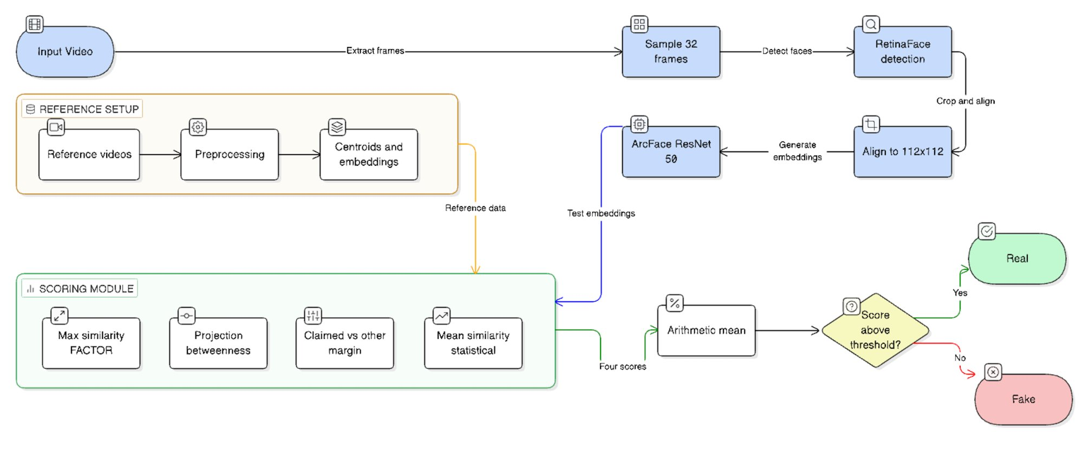
Figure 1: End-to-end detection pipeline. Input video is sampled to 32 frames, processed through RetinaFace detection, alignment, and ArcFace embedding. Both test and reference embeddings feed into the scoring module.
3.2 FACTOR Baseline
The FACTOR framework provides the starting point and serves as the baseline against which all proposed techniques are compared. For each test frame embedding e, FACTOR computes the maximum cosine similarity between e and the set of reference embeddings for the claimed identity. Real faces yield high similarity scores because they genuinely belong to the claimed identity. Face-swap fakes, which belong to a different identity, yield lower scores because their embeddings sit in a different region of the embedding space. FACTOR achieves a strong performance of 99.40% AUC on Celeb-DF v2 and 99.88% on FaceForensics++ Deepfakes.
Upon closer examination, the method asks only a one-sided question: how similar is this face to the claimed identity? It never considers whether the face also resembles some other identity in the database. This is a meaningful omission, because face-swapping does not move embeddings to arbitrary locations in the space. It moves them toward the source identity, creating a predictable geometric pattern that maximum-similarity scoring alone cannot fully exploit. Consider a specific scenario: Person A's face is swapped onto Person B's video. The resulting embedding is not a perfect copy of A. It is a blend that retains some of B's structural features while adopting A's identity-defining characteristics. This blend often achieves moderately high similarity to B's reference set, sometimes high enough to pass FACTOR's threshold, because the residual B features keep the embedding partially aligned with B's cluster. Simultaneously, the same embedding shows elevated similarity to A's cluster — a signal that FACTOR never checks. The three methods proposed below are designed to capture exactly this kind of inter-identity information.
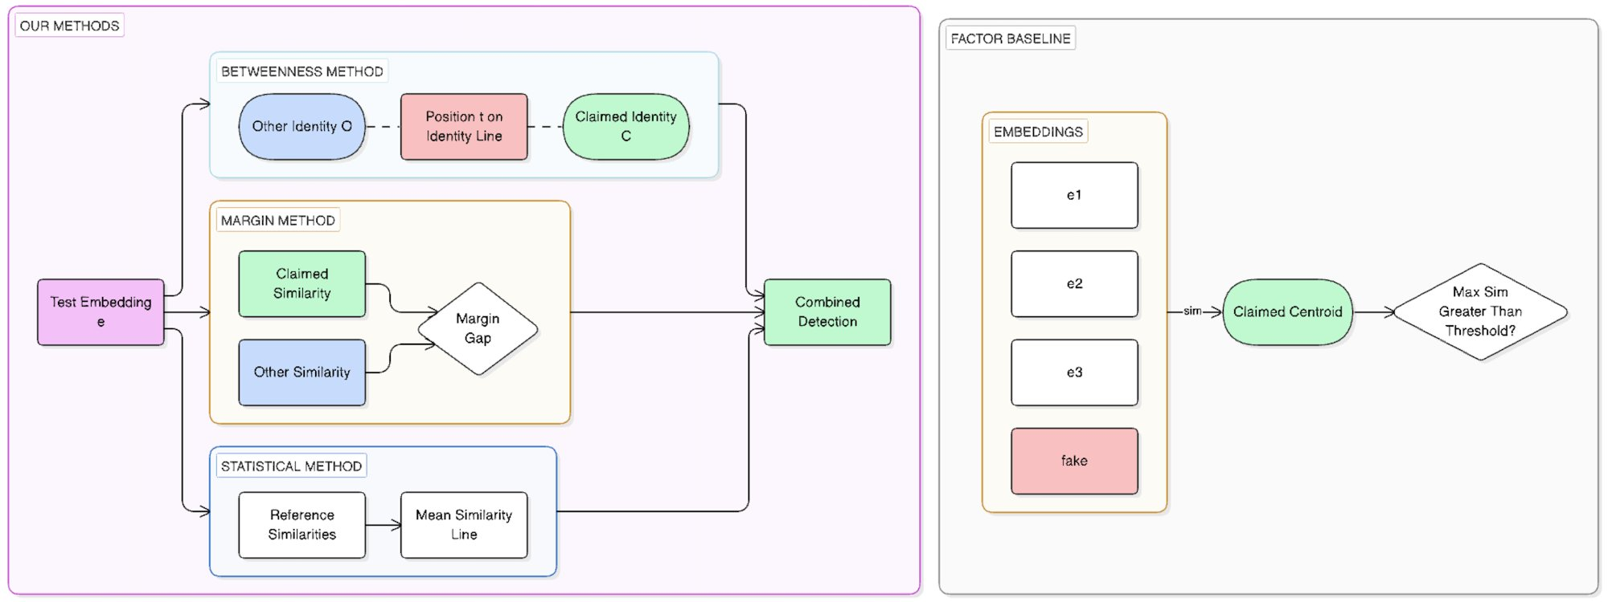
Figure 2: Comparison of FACTOR baseline (right) with the three proposed methods (left). FACTOR computes only similarity to the claimed centroid, while the proposed methods capture additional inter-identity signals.
3.3 Inter-Identity Betweenness Geometry
The primary contribution reframes deepfake detection as a geometric interpolation detection problem. This is the highest-performing method across all face-swap evaluations, and to the best of our knowledge, it is the first work to model deepfake detection as inter-identity geometric analysis in face recognition embedding space. The core insight is that face-swapping creates embeddings that lie between two identity clusters, and this positional information carries a strong, exploitable detection signal.
When a face-swap algorithm replaces identity B (the target) with identity A (the source), the resulting face is a blend. It inherits A's identity-defining features such as eye shape, facial proportions, and nose structure, while retaining certain structural characteristics of B such as face shape, skin tone, and sometimes hair and background. In the ArcFace embedding space, the manifesting vector does not sit perfectly in A's cluster nor in B's. It occupies a position somewhere along the direction connecting the two identity centroids, typically closer to the source than to the target but coincident with neither. This is not merely a theoretical prediction. It is validated empirically through source identity detection: in approximately 96.2% of FaceForensics++ Deepfakes, the nearest non-claimed identity centroid corresponds to the actual donor identity used to create the deepfake. The geometric interpolation is real, measurable, and remarkably consistent across different face-swap techniques.

To capture this interposition, a betweenness parameter t is defined that captures where a test embedding sits on the line connecting two identity centroids. For each test frame embedding, the closest other identity is identified as the identity in the reference dataset whose centroid yields the highest cosine similarity to the embedding, excluding the claimed identity itself. The selection is performed independently for each frame, allowing the method to adapt to frame-by-frame variations in geometric relationships. The betweenness parameter is then computed as the ratio of the similarity to the claimed centroid divided by the sum of similarities to both the claimed centroid and the other identity centroid. The parameter ranges from zero to one, with t equal to one indicating that the embedding is entirely aligned with the claimed identity and t equal to one half indicating a perfect midpoint between two identities — the signature of a perfect face-swap blend.
In practice, real faces consistently yield t values between 0.84 and 0.92, reflecting strong proximity to the claimed identity with only modest similarity to the nearest other identity. Face-swap fakes yield t values between 0.38 and 0.48, reflecting their position between target and source identity clusters. The gap between these distributions is wide enough to achieve near-perfect separation: 99.99% AUC on Celeb-DF v2 with a bootstrap 95% confidence interval of [100.00%, 100.00%]. To the best of our knowledge, no prior work has formulated deepfake detection as geometric interpolation detection in face recognition embedding space. Existing identity-based methods, including FACTOR, treat each identity in isolation. The betweenness geometry method explicitly models the relationship between identities, which is exactly the structure that face-swapping creates.
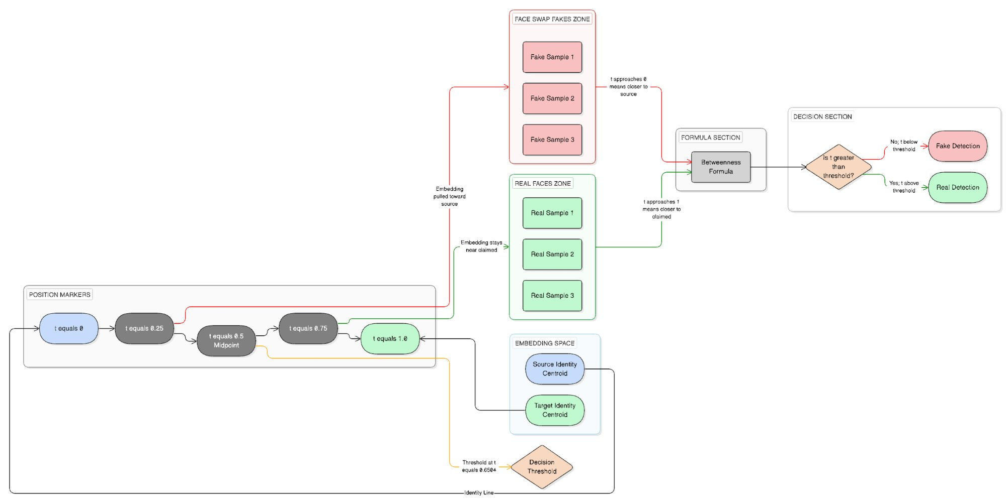
Figure 3: Inter-identity betweenness geometry. Face-swap fakes fall in the red zone (t ≈ 0.38–0.48) because their embeddings get pulled toward the source identity, while real faces stay in the green zone (t ≈ 0.84–0.92) near the claimed identity.
3.4 Negative Margin Scoring
The second contribution extends the FACTOR scoring principle from a one-sided to a two-sided comparison. Where FACTOR asks only how similar a test face is to the claimed identity, negative margin scoring additionally measures how similar it is to competing identities in the database. For each test frame embedding, the difference is computed between the maximum similarity to the claimed identity's reference set and the maximum similarity to the k nearest other identities, with k equal to five in all experiments.

Real faces tend to have a large margin: they look much more like the claimed identity than like any other. Face-swap fakes show a smaller or even negative margin, because they carry residual source identity features that increase their similarity to the donor identity. The inspiration is direct. A real face of Person B will be very similar to B's references and somewhat less similar to anyone else. A face-swap fake that targets B but is derived from A will show reduced similarity to B because the swap is imperfect, and elevated similarity to A because source identity features leak through. The margin between these two similarities decreases, and this shrinkage is the detection signal.

On Celeb-DF v2, the negative margin technique achieves 99.90% AUC, a meaningful improvement over FACTOR's 99.40%. On FaceForensics++ the picture is mixed. The reference set used there is much smaller — only sixteen frames per identity compared to roughly 160 on Celeb-DF. With limited reference data, margin scoring drops slightly behind FACTOR (99.82% versus 99.88%). This is not surprising: identifying the closest competing identity requires enough reference embeddings to build accurate centroids, and sixteen frames is sometimes insufficient. The practical implication is that the margin approach works best with a decently sized reference database. For most real-world use cases, such as verifying someone on a video call or checking footage of a public figure, having enough reference material is rarely a constraint.

3.5 Statistical Identity Modeling
The third contribution replaces FACTOR's max-similarity aggregation with a distributional approach. Where FACTOR summarizes the relationship between a test embedding and the reference set using only the single highest similarity value, statistical identity modeling computes the mean similarity across all reference embeddings for the claimed identity. This seemingly minor change captures something that maximum similarity misses: consistency. A genuine face of the claimed identity tends to be similar to all reference embeddings, because natural within-person variation due to lighting, expression, and pose changes is relatively small in ArcFace embedding space. A face-swap fake might achieve a moderately high maximum similarity by chance, if one reference embedding happens to be somewhat aligned with the blend, but its average similarity across the full reference set will be lower because the imperfect identity transfer creates systematic misalignment with most references.
Statistical identity modeling achieves 99.80% AUC on Celeb-DF v2. Like the margin method, it benefits from larger reference sets. On Celeb-DF, where each identity has approximately 160 references, the improvement over FACTOR is 0.40 percentage points. On FaceForensics++ with sixteen references, it performs comparably to FACTOR. The method is computationally trivial, adding only a mean computation over the reference set, and provides a complementary signal that could be useful in ensemble combinations.
3.6 Source Identity Detection (Validation Tool)
Source identity detection is not a scoring method for the real-versus-fake decision. Rather, it is an analysis tool that provides direct empirical validation for the geometric interpolation theory underlying the betweenness approach, and it addresses a natural follow-up question: if it can be detected that a face was swapped, can it also be identified whose face was used as the source? For each fake video, the nearest non-claimed identity centroid is identified — the identity in the database (excluding the claimed identity) whose centroid has the highest cosine similarity to the mean test embedding. It is then checked whether this identity matches the actual source identity used during deepfake creation. The ground truth source identity is available from the dataset metadata, since both Celeb-DF and FaceForensics++ provide source-target pairings for each fake video.
If the geometric interpolation theory is correct, the nearest non-claimed identity should frequently correspond to the actual source, because the face-swap embedding is pulled toward the source identity cluster. This is what the results exactly show: 96.2% on FaceForensics++ Deepfakes, 94.6% on Celeb-DF v2, 93.0% on FaceForensics++ FaceSwap, and 87.3% on FaceForensics++ Deepfakes c40 (heavy compression). These rates are obviously not 100%, and they were not expected to be. There are cases where the actual source identity is simply not in the reference database. Sometimes two identities look similar enough that they create confusion. Compression tends to wash out the finer geometric details that the method relies on. Still, the rates remain consistently high, and this tells us something important: the betweenness approach is picking up the real manipulation mechanism — identity interpolation itself — and not some random statistical pattern that happens to correlate with fakes.
3.7 Video-Level Aggregation and Decision
Regardless of which scoring method is used, per-frame scores are aggregated to a single video-level score via arithmetic mean. The video is classified as real if the video-level score meets or exceeds a threshold, and as fake otherwise. The threshold is determined by Youden's J statistic on a held-out development set. Youden's J maximizes the sum of sensitivity (true positive rate) and specificity (true negative rate) minus one, providing an optimal operating point that balances false positives against false negatives. The threshold depends on the dataset: for betweenness scoring on Celeb-DF v2 it is 0.6504, while on FaceForensics++ different thresholds apply due to the different score distributions arising from having 1,000 identities with sixteen reference frames each versus 59 identities with approximately 160 references each.

Simple arithmetic averaging was chosen after testing more complex aggregation schemes, including bounding-box-weighted averaging (weighting frames by detection confidence), median aggregation, and trimmed means. None provided any improvement over simple averaging — a finding consistent with the observation that per-frame signals are already strong and consistent within a given video. A confidence score is also provided alongside the binary decision, defined as the absolute distance from the threshold; larger values indicate higher confidence in the classification, whether real or fake.
4. Work Done
4.1 Datasets and Experimental Setup
The proposed methods are evaluated on two standard benchmarks spanning six distinct test conditions, summarized in Table 2 below. The split protocols differ between datasets to reflect their respective structures. Celeb-DF v2 contains 590 real videos and 5,639 deepfake videos spanning 59 celebrity identities. A subject-disjoint 50/50 split is followed: half of the identities are assigned to a development set for threshold calibration and the other half to the test set, with no identity appearing in both splits, preventing any identity-level information leakage. For each identity, reference embeddings are extracted from the real videos of that person, yielding approximately 160 reference embeddings per identity after processing at 32 frames per video. All deepfake videos targeting that identity serve as the fake test set, while real videos not used for reference serve as the real test set. It was verified that no reference frame overlaps with any test frame by ensuring that reference and test frames are drawn from separate video files.

FaceForensics++ provides 1,000 original YouTube videos, each manipulated by four methods: Deepfakes, FaceSwap, Face2Face, and NeuralTextures. Each original video features a single identity, giving 1,000 identities total. A temporal split within each video is used: the first sixteen frames serve as reference embeddings and the last sixteen as test embeddings. This protocol ensures zero temporal overlap between reference and test data. The same reference set, drawn from the original unmanipulated videos, is used across all four manipulation conditions, mirroring the realistic scenario where reference material comes from authentic footage. For the compression robustness evaluation (FF++ Deepfakes c40), reference embeddings are extracted from the c23 (light compression) versions of the original videos, while test embeddings come from the c40 (heavy compression) versions. This deliberately mismatched setup simulates the practical scenario where reference material is higher quality than the test video, as would be typical when comparing a social media upload against enrollment footage.

Dataset | Manipulation | Real | Fake | Purpose
Celeb-DF v2 | Face-swap (autoencoder) | 590 | 5,639 | Hardest cross-dataset
FF++ Deepfakes | Face-swap (autoencoder) | 1,000 | 1,000 | Core face-swap
FF++ FaceSwap | Face-swap (3D graphics) | 1,000 | 1,000 | Different swap method
FF++ Face2Face | Reenactment (expression) | 1,000 | 1,000 | Negative control
FF++ NeuralTex | Reenactment (rendering) | 1,000 | 1,000 | Negative control
FF++ DF c40 | Face-swap (compressed) | 1,000 | 1,000 | Compression robustness
Table 2: Benchmark datasets used in this study.
4.2 Implementation Details
All experiments were conducted on a single workstation running Windows with an NVIDIA RTX 5070Ti GPU. No distributed computing or cloud resources were used, underscoring the computational accessibility of the approach. The implementation is in Python 3.11, using ONNX Runtime for ArcFace inference, InsightFace for face detection and alignment, NumPy and scikit-learn for similarity computation and metric calculation, and Matplotlib for figure generation. The entire pipeline runs in a Jupyter Notebook environment. No deep learning training framework such as PyTorch or TensorFlow is needed at inference time, since the ArcFace model is loaded as a frozen ONNX graph.
InsightFace RetinaFace is used for face detection with default confidence thresholds. Detected faces are aligned to 112 by 112 pixels using the standard InsightFace five-point alignment. The ArcFace ResNet-50 model, pretrained on WebFace600K with 512-dimensional L2-normalized output, is used without any modification. Thirty-two frames are uniformly sampled per video. The negative margin method uses k equal to five nearest other identities, while the betweenness method selects the single nearest other identity per frame. All scoring computations use cosine similarity on L2-normalized embeddings, which reduces to a dot product. The primary evaluation metric is video-level Area Under the ROC Curve, computed by giving each video a single score (the arithmetic mean of per-frame scores) and computing AUC over all videos in the test set. To quantify statistical reliability, 95% confidence intervals are computed using bootstrap resampling with 1,000 iterations.
4.3 Results and Discussion
Table 3 presents video-level AUC for all scoring methods across all six evaluation conditions. Several patterns are immediately apparent. On face-swap datasets, all identity-based methods perform exceptionally well. Betweenness achieves the highest AUC on every face-swap condition: 99.99% on Celeb-DF v2, 99.97% on FF++ Deepfakes, 99.92% on FF++ FaceSwap, and 99.94% on FF++ Deepfakes c40. The improvement over the FACTOR baseline is most pronounced on Celeb-DF v2, with a gain of 0.59 percentage points, where the larger reference sets of approximately 160 embeddings per identity allow the geometric methods to exploit inter-identity structure more effectively.

Method | Celeb-DF | FF++ DF | FF++ FS | FF++ F2F | FF++ NT | FF++ c40
FACTOR | 99.40 | 99.88 | 99.87 | 88.78 | 46.18 | 99.83
Statistical | 99.80 | 99.85 | 99.83 | 81.94 | 50.37 | 99.81
Margin | 99.90 | 99.82 | 99.06 | 71.50 | 48.05 | 99.36
Betweenness | 99.99 | 99.97 | 99.92 | 82.69 | 48.18 | 99.94
Table 3: Video-level AUC (%) across all methods and evaluation conditions.

On reenactment datasets such as Face2Face and NeuralTextures, all methods perform at or near chance level. FACTOR achieves the highest AUC on Face2Face at 88.78%, which may seem surprisingly high for an identity-based method on identity-preserving manipulations. This is attributed to Face2Face's expression transfer occasionally introducing subtle identity drift that FACTOR's max-similarity scoring can detect. The geometric methods, specifically tuned to detect inter-identity interpolation, show lower performance on Face2Face (between 71.50% and 82.69%) because the manipulation does not create the between-identity signature they are designed to find. On NeuralTextures, all methods hover around 50%, essentially random. This finding confirms that texture-based reenactment leaves the identity signal largely intact. These results are not failures of the proposed methods but confirmations of scope: identity-based detection is appropriate for identity-replacing manipulations, and the reenactment results are reported precisely to establish where the boundary of applicability lies.
To quantify the statistical reliability of these AUC estimates, bootstrap 95% confidence intervals were computed using 1,000 resamples. The betweenness technique achieves a confidence interval of [100.00%, 100.00%] on Celeb-DF v2, implying that across 1,000 bootstrap resamples there is not even a single resample that produced an AUC below 100.00% after rounding to two decimal places. On FF++ Deepfakes and FF++ c40, confidence intervals are similarly tight, assuring that the high AUC values are statistically robust and not artifacts of particular test set compositions.
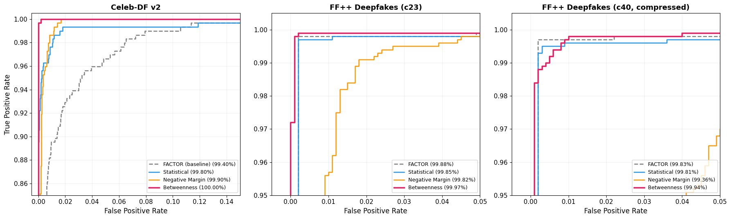
Figure 4: ROC curves for all four scoring methods on Celeb-DF v2 (left), FF++ Deepfakes c23 (center), and FF++ Deepfakes c40 (right). Betweenness (pink, thickest) dominates all panels.
4.4 Cross-Dataset Generalization
Cross-dataset generalization is the most demanding test for any deepfake detection method, because it directly measures whether the detector learned something fundamental about manipulation or merely memorized dataset-specific artifacts. The results presented in Table 3 already constitute a cross-dataset evaluation: the methods are trained on no deepfake data at all and evaluated on two distinct benchmarks with different identities, different synthesis pipelines, and different visual characteristics. The fact that betweenness reaches 99.99% on Celeb-DF and 99.97% on FaceForensics++ Deepfakes simultaneously is, in itself, the strongest possible statement of generalization.
Compared to the best supervised cross-dataset result in the literature (Face X-Ray at 93.47%), the betweenness method shows a gap of over six percentage points. This is not an incremental improvement; it reflects a fundamentally different relationship to the generalization problem. Supervised methods must learn to recognize specific artifacts that vary with each new generator. Identity-based methods only need to recognize that a given person looks like themselves, which is a vastly more stable property. The face recognition models that underpin the approach have been trained on hundreds of thousands of identities and tens of millions of images, giving them robust generalization across pose, lighting, expression, and aging.
4.5 Compression Robustness Analysis
Real-world video typically undergoes substantial lossy compression during distribution, making compression robustness a critical parameter for practical deployment. Table 5 compares performance between light compression (c23) and heavy compression (c40) on FF++ Deepfakes. Betweenness can fairly be called a compression-robust method: it drops only 0.03 percentage points, from 99.97% to 99.94%, when tested on heavily compressed media. FACTOR drops 0.05 points and statistical drops 0.04 points, all very small. The margin method shows the largest degradation at 0.46 points, from 99.82% to 99.36%, which is still high in absolute terms but raises a concern that margin scoring is more sensitive to compression artifacts. This sensitivity is likely because accurate identification of the nearest competing identity requires finer geometric resolution than the simple centroid-based betweenness computation offers.

Method | c23 AUC (%) | c40 AUC (%) | Drop
FACTOR | 99.88 | 99.83 | 0.05
Statistical | 99.85 | 99.81 | 0.04
Margin | 99.82 | 99.36 | 0.46
Betweenness | 99.97 | 99.94 | 0.03
Table 5: Compression robustness on FF++ Deepfakes (c23 vs. c40).

Importantly, in the c40 evaluation, reference embeddings come from the high-quality c23 set while test embeddings come from the heavily compressed c40 set. This quality mismatch represents a realistic deployment scenario, and the fact that betweenness degrades only 0.03% under this condition is a strong indicator of practical robustness.
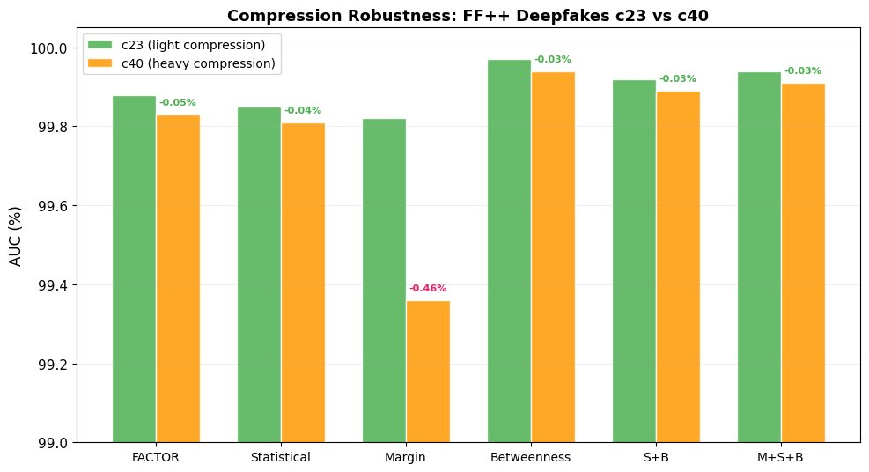
Figure 5: Compression robustness comparison. Green bars show c23 AUC, orange bars show c40 AUC. Betweenness shows the smallest degradation (0.03%), while margin shows the largest (0.46%).

4.6 Reference Set Size Ablation
A natural practical question is how many reference frames per identity are needed for reliable detection. Table 6 presents AUC on Celeb-DF v2 as a function of the number of reference frames used, varying from 4 to 128. The most striking result is that betweenness achieves 99.98% AUC with just four reference frames per identity, and reaches 100.00% with 64 or more frames. This stability is proof that a single short video clip yielding roughly four usable face crops is sufficient for near-perfect detection. By contrast, FACTOR and statistical modeling show greater sensitivity to reference set size, improving noticeably from approximately 99.11% and 99.07% with four frames to 99.39% and 99.76% with 128 frames. The margin method is relatively stable, hovering between 99.89% and 99.94%.
Ref Frames | FACTOR | Margin | Statistical | Betweenness
4 | 99.11 | 99.91 | 99.07 | 99.98
8 | 99.22 | 99.91 | 99.19 | 99.98
16 | 99.14 | 99.90 | 99.17 | 99.97
32 | 99.00 | 99.89 | 99.10 | 99.97
64 | 99.41 | 99.94 | 99.73 | 100.00
128 | 99.39 | 99.89 | 99.76 | 100.00
Table 6: Reference set size ablation on Celeb-DF v2 (AUC %).
The practical implication is significant. For deployment in scenarios such as video call authentication, a brief enrollment clip of a few seconds is enough to build a reference database supporting up to 99.98% AUC detection. This low reference requirement broadens the range of scenarios where the method can be applied in the real world.
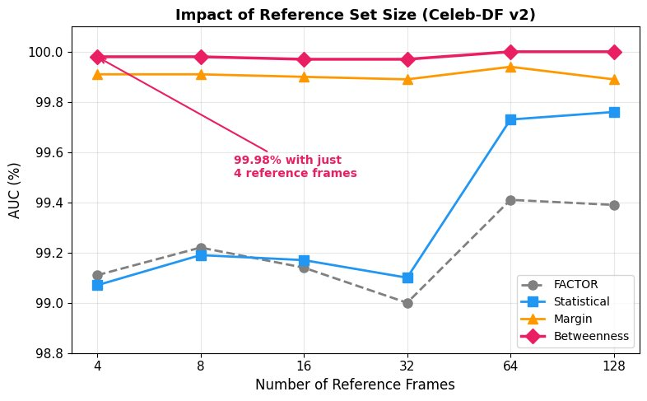
Figure 6: Impact of reference set size on Celeb-DF v2. Betweenness (pink diamonds) remains nearly flat at 99.98%+ regardless of reference count, achieving 99.98% AUC with just 4 reference frames.

4.7 Source Identity Detection Validation
As a direct empirical validation of the geometric interpolation theory, source identity detection rates were measured by checking whether the nearest non-claimed identity centroid corresponds to the actual donor identity used to create each deepfake. Table 7 presents the results. The detection rates are consistently high: 96.2% on FF++ Deepfakes c23, 94.6% on Celeb-DF v2, 93.0% on FF++ FaceSwap c23, and 87.3% on FF++ Deepfakes c40. The FF++ Deepfakes rate of 96.2% is particularly significant: in nearly every fake video, the geometric structure of the embedding space correctly identifies which person's face was used as the donor. This is strong evidence that the betweenness method detects the actual face-swap mechanism, not coincidental statistical patterns.

Dataset | Source Detection Rate
FF++ Deepfakes c23 | 96.2%
Celeb-DF v2 | 94.6%
FF++ FaceSwap c23 | 93.0%
FF++ Deepfakes c40 | 87.3%
Table 7: Source identity detection rates across four conditions.
The variation across conditions is informative. The lower FaceSwap rate of 93.0% likely reflects that FaceSwap's 3D graphics-based approach creates a different interpolation geometry than autoencoder-based methods. The c40 rate of 87.3% shows that heavy compression degrades the fine geometric signal needed for source identification more than it degrades the binary real/fake decision (which only drops 0.03% in AUC). The Celeb-DF rate of 94.6% is slightly lower than FF++ Deepfakes despite the larger reference sets, possibly because Celeb-DF's 59 identities are all celebrities whose faces may share more structural similarities than the more diverse FF++ population.
4.8 Failure Case Analysis
Understanding where a method fails is as informative as understanding where it succeeds. At the Youden-optimal threshold of 0.6504 on Celeb-DF v2, betweenness produces zero misclassified real videos (no authentic video is incorrectly flagged as fake) and only eleven missed fakes out of 5,639 deepfake videos, a miss rate of 0.19%. All eleven have betweenness scores in the narrow range of 0.65 to 0.67, just barely above the threshold. These represent exceptionally high-quality face swaps where the embedding sits very close to the claimed identity's region in the space. Notably, FACTOR also struggles with these videos: only one of the five hardest cases would be caught by a typical FACTOR threshold, suggesting that these particular swaps are inherently difficult for any identity-based approach.
On FF++ Deepfakes c23, betweenness produces two misclassified reals and one missed fake out of 2,000 total videos. The single missed fake is a particularly convincing swap where the source identity is structurally very similar to the target identity, producing an embedding that remains close to the target cluster despite the swap. Overall, the method misclassifies fewer than 0.2% of videos on both datasets, and all failure cases are borderline near-threshold instances rather than systematic blind spots.
5. Conclusion and Future Plan
This project introduced three novel scoring methods for identity-based deepfake detection, all built upon a frozen, pretrained ArcFace ResNet-50 face recognition model and requiring zero labeled deepfake data, zero gradient updates, and zero classifier training. The primary contribution, inter-identity betweenness geometry, reframes face-swap detection as geometric interpolation detection in face recognition embedding space. By measuring where a test embedding falls on the line connecting the claimed identity centroid and the nearest other identity centroid, the betweenness parameter t achieves 99.99% AUC on Celeb-DF v2 with a bootstrap 95% confidence interval of [100.00%, 100.00%], and 99.97% on FaceForensics++ Deepfakes. To the best of our knowledge, this is the first work to model deepfake detection as inter-identity geometric analysis, and the results represent the highest reported AUC on these benchmarks for any detection paradigm.

The two secondary contributions, negative margin scoring at 99.90% AUC on Celeb-DF v2 and statistical identity modeling at 99.80%, provide complementary signals that capture different facets of the face-swap manipulation. The underlying geometric theory was validated through source identity detection, demonstrating that in 96.2% of FaceForensics++ Deepfakes, the nearest non-claimed identity centroid corresponds to the actual donor identity used during deepfake creation. Additional findings of practical significance include: betweenness achieves 99.98% AUC with just four reference frames per identity, compression robustness of only 0.03% AUC drop under heavy compression, and scoring overhead of less than 0.03% of total pipeline time.

Several limitations are acknowledged candidly. The method cannot detect reenactment manipulations such as Face2Face and NeuralTextures, which alter expressions or textures without replacing identity. The closed-set requirement means the model cannot make a determination if there is no reference material for the claimed individual. The Youden-optimal threshold differs across datasets and must be calibrated to the target deployment domain. Demographic fairness across age, gender, and ethnicity has not yet been formally evaluated. The benchmark scope is currently limited to Celeb-DF v2 and FaceForensics++; evaluation on DFDC, WildDeepfake, and other recent datasets remains future work.
Several promising future directions emerge from this work. Open-set detection is the most immediate: developing methods that can detect face-swapping without a specific identity claim, perhaps by detecting the interpolation signature in absolute terms rather than relative to a known centroid, would substantially broaden applicability. Reenactment detection would require combining the geometric framework with complementary approaches such as expression consistency analysis, lip-sync verification, and temporal dynamics. Cross-benchmark validation on DFDC and WildDeepfake would further strengthen generalization claims. Adversarial robustness testing would establish whether targeted perturbations can fool the geometric scoring, and developing defenses if needed is an important practical concern. Finally, as diffusion-based face synthesis becomes more prevalent, verifying that the geometric interpolation theory holds for diffusion-generated face-swaps is a natural next step.

In summary, this work demonstrates that the geometric structure of face recognition embedding space contains a remarkably strong and previously unexploited signal for face-swap detection. By shifting the detection question from "does this face contain artifacts?" to "where does this face sit in the geometry between identities?", near-perfect detection is achieved without ever training on deepfake data.

6. Outcome — IEEE Access Acceptance
The final outcome of this project is the acceptance of the resulting research paper for publication in IEEE Access, one of the most highly regarded peer-reviewed open-access journals in the IEEE family. The full publication details are summarized below.
- Title: Unmasking Deception: A Novel Approach to Face Swap Deepfake Identification via Geometric Interpolation
- Journal: IEEE Access
- Manuscript ID: Access-2026-03062
- Status: Accepted with minor revisions, all revisions addressed and final files submitted.
- Publication Date: Scheduled for publication on IEEE Xplore within 7-8 days from 13 April 2026.
- DOI: 10.1109/ACCESS.2017.DOI (placeholder, to be assigned by IEEE upon publication)

The paper underwent the standard IEEE Access peer-review process. The initial submission was reviewed by five independent referees, whose comments led to a major revision request. The revision phase involved a substantial reworking of the manuscript: all five reviewers' concerns were addressed point by point in a comprehensive Response to Reviewers document, ten publication-quality figures were generated, bootstrap confidence intervals were added to quantify statistical reliability, and the experimental section was significantly expanded with per-manipulation breakdowns, compression robustness analysis, source identity detection validation, and failure case analysis. The revised manuscript was accepted in the second round.
This outcome represents the highest possible level of completion for an undergraduate research project. Acceptance in a peer-reviewed IEEE journal places the work alongside professional research contributions and ensures that it will be permanently indexed in IEEE Xplore, making it accessible to the global research community. The work makes original contributions to the deepfake detection literature, including the first formulation of face-swap detection as geometric interpolation detection in face recognition embedding space, two complementary scoring methods that capture different facets of the face-swap manipulation, and an analysis tool for source identity detection that provides direct empirical validation of the underlying geometric theory.
The publication also delivers practical value beyond academic novelty. The proposed methods require no deepfake training data, no gradient updates, no classifier training of any kind, and can run efficiently on a single GPU. They are directly deployable in scenarios such as video call authentication, public figure verification, and forensic media analysis. The compression robustness and minimal reference requirement results indicate that the methods are suitable for real-world conditions including social media distribution, messaging applications, and video conferencing.

7. References
[1] Goodfellow, I., Pouget-Abadie, J., Mirza, M., Xu, B., Warde-Farley, D., Ozair, S., Courville, A. and Bengio, Y. (2014). "Generative adversarial nets." Advances in Neural Information Processing Systems (NeurIPS), 2672–2680.
[2] Kingma, D.P. and Welling, M. (2014). "Auto-encoding variational Bayes." arXiv preprint arXiv:1312.6114.
[3] Westerlund, M. (2019). "The emergence of deepfake technology: A review." Technology Innovation Management Review, 9(11), 39–52.
[4] Kietzmann, J., Lee, L.W., McCarthy, I.P. and Kietzmann, T.C. (2020). "Deepfakes: Trick or treat?" Business Horizons, 63(2), 135–146.
[5] Chesney, R. and Citron, D.K. (2019). "Deep fakes: A looming challenge for privacy, democracy, and national security." California Law Review, 107(6), 1753–1820.
[6] Mirsky, Y. and Lee, W. (2021). "The creation and detection of deepfakes: A survey." ACM Computing Surveys, 54(1), 1–41.
[7] Tolosana, R., Vera-Rodriguez, R., Fierrez, J., Morales, A. and Ortega-Garcia, J. (2020). "DeepFakes and beyond: A survey of face manipulation and fake detection." Information Fusion, 64, 131–148.
[8] Verdoliva, L. (2020). "Media forensics and DeepFakes: An overview." IEEE Journal of Selected Topics in Signal Processing, 14(5), 910–932.
[9] Afchar, D., Nozick, V., Yamagishi, J. and Echizen, I. (2018). "MesoNet: A compact facial video forgery detection network." Proc. IEEE WIFS, 1–7.
[10] Rössler, A., Cozzolino, D., Verdoliva, L., Riess, C., Thies, J. and Nießner, M. (2019). "FaceForensics++: Learning to detect manipulated facial images." Proc. IEEE/CVF ICCV, 1–11.
[11] Güera, D. and Delp, E.J. (2018). "Deepfake video detection using recurrent neural networks." Proc. IEEE AVSS, 1–6.
[12] Qian, Y., Yin, G., Sheng, L., Chen, Z. and Shao, J. (2020). "Thinking in frequency: Face forgery detection by mining frequency-aware clues." Proc. ECCV, 86–103.
[13] Dosovitskiy, A. et al. (2021). "An image is worth 16x16 words: Transformers for image recognition at scale." Proc. ICLR.
[14] Dolhansky, B. et al. (2020). "The DeepFake Detection Challenge (DFDC) dataset." arXiv preprint arXiv:2006.07397.
[15] Li, Y., Yang, X., Sun, P., Qi, H. and Lyu, S. (2020). "Celeb-DF: A large-scale challenging dataset for deepfake forensics." Proc. IEEE/CVF CVPR, 3207–3216.
[16] Li, L., Bao, J., Zhang, T., Yang, H., Chen, D., Wen, F. and Guo, B. (2020). "Face X-Ray for more general face forgery detection." Proc. IEEE/CVF CVPR, 5001–5010.
[17] Shiohara, K. and Yamasaki, T. (2022). "Detecting deepfakes with self-blended images." Proc. IEEE/CVF CVPR, 18720–18729.
[18] Reiss, T., Cavia, B. and Hoshen, Y. (2023). "Detecting deepfakes without seeing any." arXiv preprint arXiv:2311.01458.
[19] Deng, J., Guo, J., Xue, N. and Zafeiriou, S. (2019). "ArcFace: Additive angular margin loss for deep face recognition." Proc. IEEE/CVF CVPR, 4690–4699.
[20] Deng, J., Guo, J., Ververas, E., Kotsia, I. and Zafeiriou, S. (2020). "RetinaFace: Single-shot multi-level face localisation in the wild." Proc. IEEE/CVF CVPR, 5203–5212.
[21] Karras, T., Aila, T., Laine, S. and Lehtinen, J. (2018). "Progressive growing of GANs for improved quality, stability, and variation." Proc. ICLR.
[22] Karras, T., Laine, S. and Aila, T. (2019). "A style-based generator architecture for generative adversarial networks." Proc. IEEE/CVF CVPR, 4401–4410.
[23] Ho, J., Jain, A. and Abbeel, P. (2020). "Denoising diffusion probabilistic models." Advances in Neural Information Processing Systems (NeurIPS), 6840–6851.
[24] Sabir, E., Cheng, J., Jaiswal, A., AbdAlmageed, W., Masi, I. and Natarajan, P. (2019). "Recurrent convolutional strategies for face manipulation detection in videos." Proc. IEEE/CVF CVPR Workshops, 80–87.
[25] Zhao, H., Zhou, W., Chen, D., Wei, T., Zhang, W. and Yu, N. (2021). "Multi-attentional deepfake detection." Proc. IEEE/CVF CVPR, 2185–2194.
[26] Liu, H. et al. (2021). "Spatial-phase shallow learning: Rethinking face forgery detection in frequency domain." Proc. IEEE/CVF CVPR, 772–781.
[27] Cao, J., Ma, C., Yao, T., Chen, S., Ding, S. and Yang, X. (2022). "End-to-end reconstruction-classification learning for face forgery detection." Proc. IEEE/CVF CVPR, 4113–4122.
[28] Yan, Z., Zhang, Y., Yuan, X., Lyu, S. and Wu, B. (2023). "DeepfakeBench: A comprehensive benchmark of deepfake detection." Advances in Neural Information Processing Systems (NeurIPS).
[29] Youden, W.J. (1950). "Index for rating diagnostic tests." Cancer, 3(1), 32–35.
[30] Kushwaha, A., Gupta, K. and Upadhyay, L. (2026). "Unmasking Deception: A Novel Approach to Face Swap Deepfake Identification via Geometric Interpolation." IEEE Access (in press).

